
FACULTY OF TECHNOLOGY
Department of CE – AI ML DS 01AI0506-DESIGN AND ANALYSIS OF ALGORITHMS

PRACTICAL-5
Aim : To find the maximum value of items that can be placed in a knapsack of capacity W without exceeding its weight limits, and to identify which items are selected, using Dynamic Programming.

Algorithm :
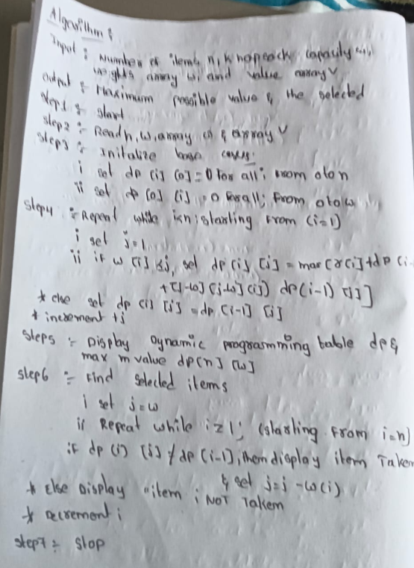

NAME: Raja kiran
ENROLLMENT NO: 92400118654 Page 1 of 7

Program / Code :
#include <iostream> #include <vector> #include <algorithm> using namespace std;
class Knapsack { private:
vector<int> w; // weights
vector<int> v; // values
int n, W; // number of items and capacity vector<vector<int>> dp; // DP table

public:

// Get Input
void getInput() {

cout << "Enter number of items : "; cin >> n;

cout << "Enter knapsack capacity : "; cin >> W;

w.resize(n + 1);
v.resize(n + 1);

// Creating DP table
// Time Complexity = O(nW) dp.assign(n + 1, vector<int>(W + 1, 0));

for (int i = 1; i <= n; i++) { cout << "Item " << i
<< " weight and value : "; cin >> w[i] >> v[i];

FACULTY OF TECHNOLOGY

Department of CE – AI ML DS 01AI0506-DESIGN AND ANALYSIS OF ALGORITHMS

}
}

// Solve Knapsack using Dynamic Programming void solve() {

// Time Complexity = O(nW) for (int i = 1; i <= n; i++) {

NAME: Raja kiran
ENROLLMENT NO: 92400118654 Page 2 of 7

for (int j = 1; j <= W; j++) { if (w[i] <= j) {
dp[i][j] = max(
v[i] + dp[i - 1][j - w[i]], dp[i - 1][j]

FACULTY OF TECHNOLOGY

Department of CE – AI ML DS 01AI0506-DESIGN AND ANALYSIS OF ALGORITHMS

);

} else {

dp[i][j] = dp[i - 1][j];
}
}
}
}

// Print DP Table void printTable() {
cout << "\nDP Table:\n "; for (int j = 0; j <= W; j++) {
cout << j << " ";
}

cout << endl;

// Time Complexity = O(nW) for (int i = 0; i <= n; i++) {
cout << "i=" << i << " "; for (int j = 0; j <= W; j++) {
cout << dp[i][j] << " ";
}

cout << endl;
}
}

// Find Selected Items void findItems() {

NAME: Raja kiran
ENROLLMENT NO: 92400118654 Page 3 of 7

FACULTY OF TECHNOLOGY

Department of CE – AI ML DS 01AI0506-DESIGN AND ANALYSIS OF ALGORITHMS

cout << "\nSelected Items:\n"; int j = W;
// Time Complexity = O(n) for (int i = n; i >= 1; i--) {
if (dp[i][j] != dp[i - 1][j]) { cout << "Item " << i
<< " (w=" << w[i]
<< ", v=" << v[i]
<< ") TAKEN\n";

j -= w[i];

} else {

cout << "Item " << i
<< " (w=" << w[i]
<< ", v=" << v[i]
<< ") NOT taken\n";
}
}
}

// Show Result
void showResult() {

cout << "\nMaximum Value = "
<< dp[n][W] << endl;
}
};
int main() { Knapsack k; k.getInput();
k.solve(); k.printTable(); k.showResult(); k.findItems();

NAME: Raja kiran
ENROLLMENT NO: 92400118654 Page 4 of 7

return 0;
}

FACULTY OF TECHNOLOGY

Department of CE – AI ML DS 01AI0506-DESIGN AND ANALYSIS OF ALGORITHMS

Output :
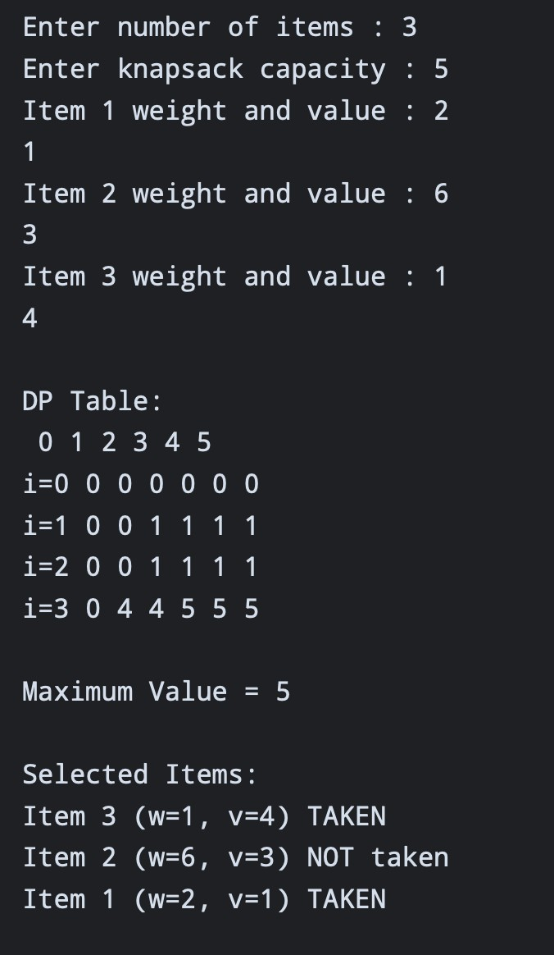

Time Complexity :

NAME: Raja kiran
ENROLLMENT NO: 92400118654 Page 5 of 7

FACULTY OF TECHNOLOGY

Department of CE – AI ML DS 01AI0506-DESIGN AND ANALYSIS OF ALGORITHMS

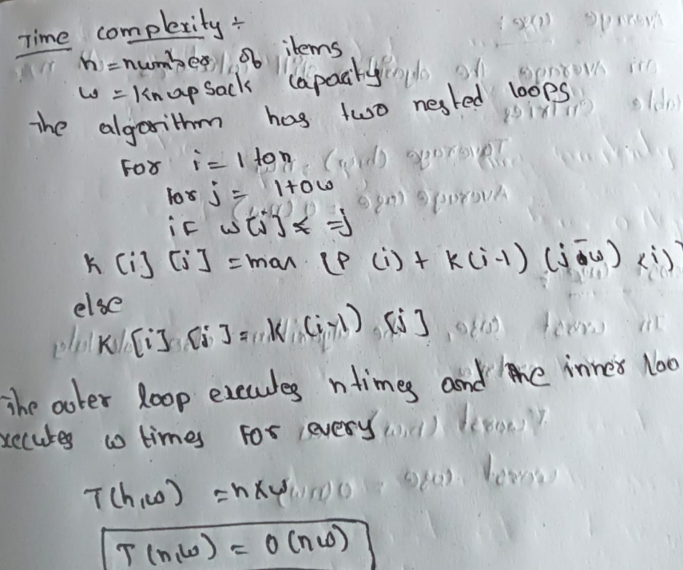

BEST CASE:

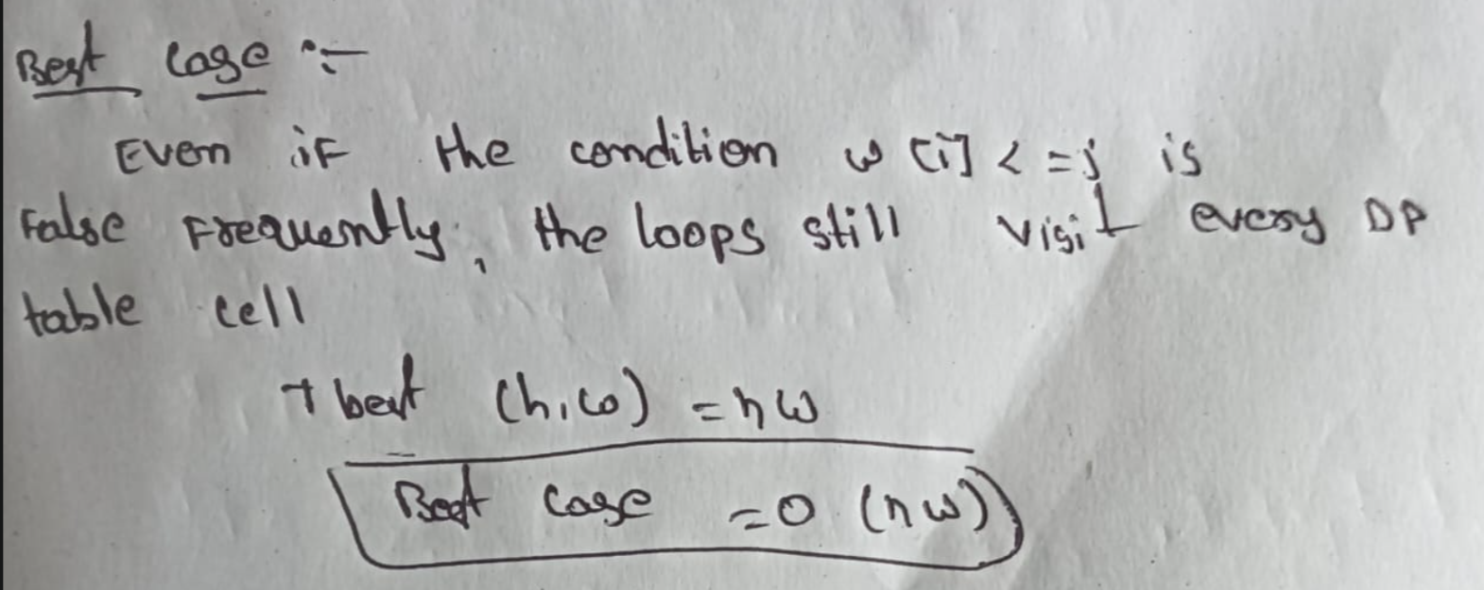

NAME: Raja kiran
ENROLLMENT NO: 92400118654 Page 6 of 7

FACULTY OF TECHNOLOGY
Department of CE – AI ML DS 01AI0506-DESIGN AND ANALYSIS OF ALGORITHMS

AVERAGE CASE:
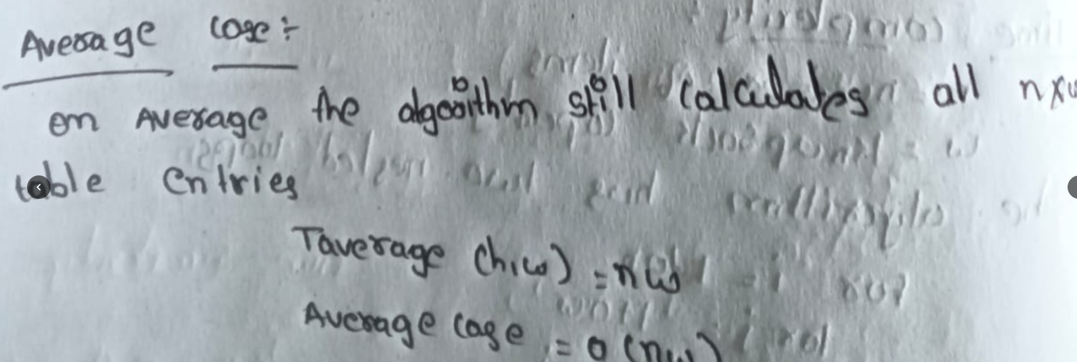

WORST CASE:
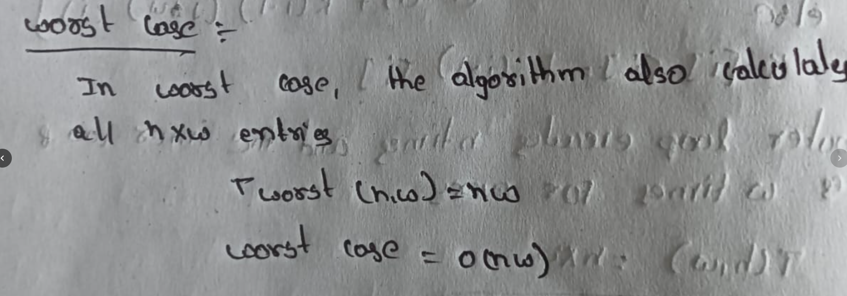

Conclusion :

The 0/1 Knapsack problem was successfully solved using Dynamic Programming. The algorithm finds the maximum possible profit by systematically filling a DP table. It has a fixed time complexity of O(n × W) for all cases, since the program evaluates each entry of the table to determine the best possible solution.

NAME:Raja kiran
ENROLLMENT NO: 92400118654 Page 7 of 7

